The King and His Kingdom
Matthew 16:13-28
King Questions ?

Intro – Review ____________________________________________________________________________
__________________________________________________________________________________________
__________________________________________________________________________________________

7 Acts of Kindness from Matthew 14 and 15  1. Feeding the 5,000  2. Strengthened the faith of the Apostles  3. Heals in remote areas  4 Removes a heavy burden  5. Kindness towards the Gentiles  6. Kindness towards the needy  7. Kindness for its own sake | 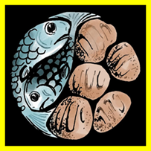  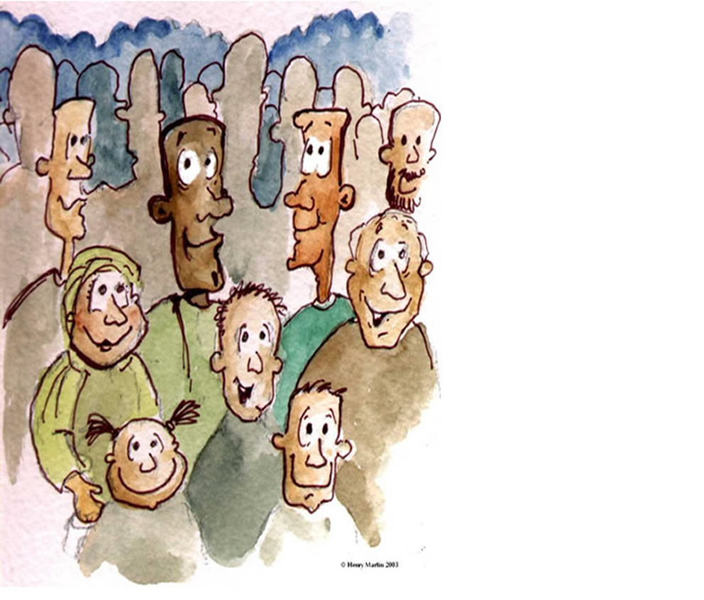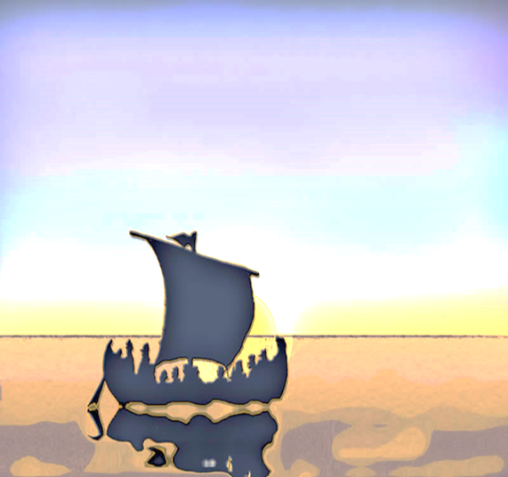

I. Turning Point for the King
Two critical events:
- Rejection by _________________________________________________________________________
____________________________________________________________________________________
- Rejection by ________________________________________________________________________
____________________________________________________________________________________
II. Ministry to the Apostles
Jesus built the faith of His Apostles in various ways:
- Confronting Jewish leaders ____________________________________________________________
____________________________________________________________________________________
____________________________________________________________________________________
1. Accusation of transgressing tradition – 15:1-20 ___________________________________________
____________________________________________________________________________________
2. Pharisees ask for a sign – 16:1-12 ______________________________________________________
____________________________________________________________________________________3. Jesus’ response to Peter’s confession – 16:13-20 __________________________________________
____________________________________________________________________________________

Teaching Beyond the Confession
- No knowledge without revelation _______________________________________________
__________________________________________________________________________
- Simon _____________________________________________________________________
___________________________________________________________________________
- Peter ______________________________________________________________________
___________________________________________________________________________
- The true “Rock” _____________________________________________________________
___________________________________________________________________________
- Apostles’ “keys”_____________________________________________________________
___________________________________________________________________________

- Miracles Performed for the Apostles ____________________________________________________
____________________________________________________________________________________
____________________________________________________________________________________
1. Walking on the Water – Matthew 22-33 _________________________________________________
____________________________________________________________________________________
____________________________________________________________________________________
2. Transfiguration – 17:1-8 _____________________________________________________________
____________________________________________________________________________________
____________________________________________________________________________________
3. The coin in the fish – 17:24-27 ________________________________________________________
____________________________________________________________________________________
____________________________________________________________________________________

- Miracles for the People _______________________________________________________________
___________________________________________________________________________________
A Boy is Healed _____________________________________________________________________
____________________________________________________________________________________________________________________________________________________________________________________________________________________________________________________________

LITTLE LEARNERS
Matthew 16

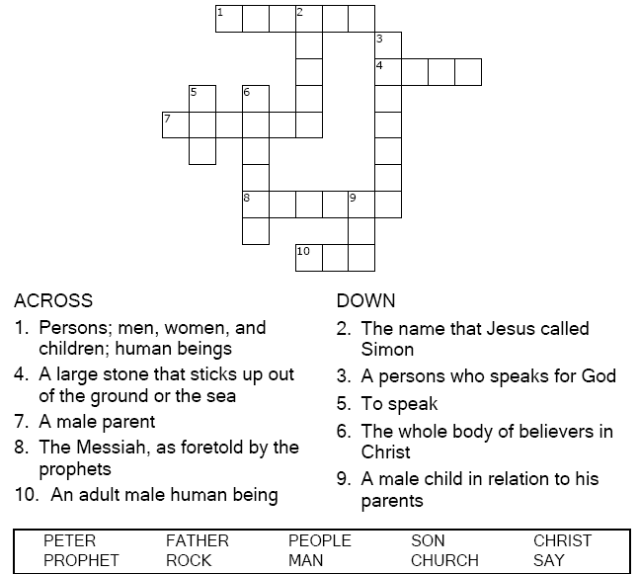  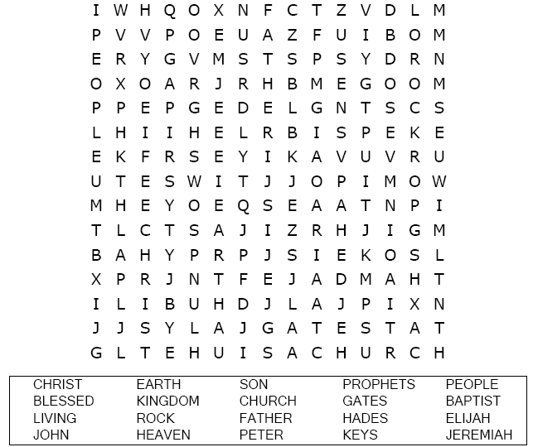 | Each number represents a letter of the alphabet. Substitute the correct letter for the numbers to reveal the codded words.  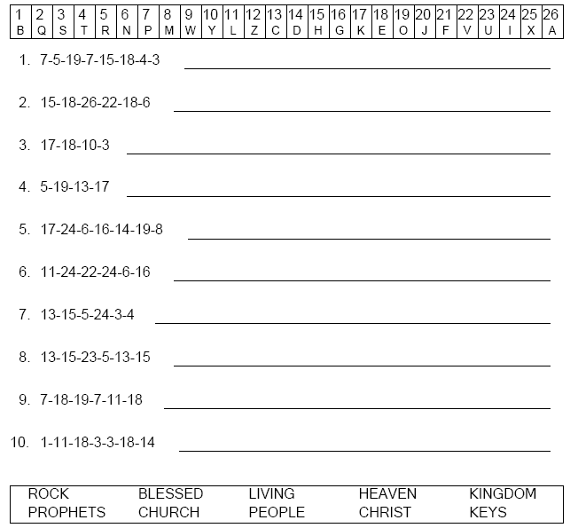  Can you find the way to Jesus, Moses, and Elijah on the mountain?  