The King and His Kingdom
Matthew 24-25 The King’s Coming

Historical Coming of Jesus Predictions: http://www.manyendings.lorenmadsen.com/

I. The King’s Judgment – Matthew 24-25
- Vs. 1-3 – The Apostles ask 3 questions:
  - ______________________________________________________________________________
  - ______________________________________________________________________________
  - ______________________________________________________________________________
- Jesus answers by describing events in three specific views of history:
  - Panoramic View – vs. 4-14________________________________________________________
____________________________________________________________________________________________________________________________________________________________
  - Microscopic to Jerusalem view – vs. 15-35___________________________________________
____________________________________________________________________________________________________________________________________________________________
  - Telescopic to 2nd coming view – vs. 16-44____________________________________________
    - Review 3 historical views.

A. “Tell us, when will these things be? Matthew 24: 5 – 28
Destruction of Jerusalem AD 70
Signs: Matthew 24:5-8 For many will come in My name, saying, ‘I am the Christ,’ and will deceive many. And you will hear of wars and rumors of wars. See that you are not troubled; for all these things must come to pass, but the end is not yet. For nation will rise against nation, and kingdom against kingdom. And there will be famines, pestilences, and earthquakes in various places. All these are the beginning of sorrows.
      - Panoramic View – Matthew 24:4-14
Vs. 4_____________________________________________________________
Vs. 5-8____________________________________________________________
__________________________________________________________________
Vs. 9-12___________________________________________________________
____________________________________________________________________________________________________________________________________
Vs. 13____________________________________________________________
Vs. 14____________________________________________________________
__________________________________________________________________
      - Telescopic to Jerusalem view – vs. 15-35_______________________________
______________________________________________________________________________________________________________________________________________________________________________________________________
Vs. 15-18__________________________________________________________
____________________________________________________________________________________________________________________________________
Vs. 19-21__________________________________________________________
____________________________________________________________________________________________________________________________________
Vs. 22____________________________________________________________
__________________________________________________________________

Vs. 23-26__________________________________________________________
____________________________________________________________________________________________________________________________________
Vs. 27____________________________________________________________
Vs. 28____________________________________________________________

B And what will be the sign of Your coming, Matthew 24: 29 – 35
End of the Roman Empire – Christianity and the Church will live
Symbolic Language:
• Isaiah speaks of the Lord riding upon a "swift cloud" to overpower Egypt (Isa. 19:1).
• The Psalms speak of the Lord riding the clouds as a chariot when he exercises his power
(Ps. 104:3).
• Daniel prophesies of a vision where "one like a son of man was coming with the clouds of
heaven, approaching the Ancient of Days" (Dan. 7:13-14).

Vs. 29____________________________________________________________
Vs. 29-31__________________________________________________________
________________________________________________________________________________________________________________________________________________________________________________________________________________________________________________________________________
Vs. 32-35__________________________________________________________
__________________________________________________________________

C. and of the end of the age?” Matthew 24: 36-51 and Matthew 25:1-13

So WHEN IS HE COMING? Matthew 24:36 “But of that day and hour
no one knows, not even the angels of heaven, but My Father only.

WILL THERE BE SIGNS? Matthew 24:37
Eating, Drinking, and Marrying

ARE YOU READY? Matthew 24:44 Therefore you also be ready, for
the Son of Man is coming at an hour you do not expect.
Matthew 25: 1 -13 Jewish Weddings
Time set by the Bridegroom

      - Telescopic to 2nd coming view – vs. 16-44_______________________________
______________________________________________________________________________________________________________________________________________________________________________________________________
Vs. 36____________________________________________________________
Vs. 37-39__________________________________________________________
____________________________________________________________________________________________________________________________________
Vs. 40-41__________________________________________________________
____________________________________________________________________________________________________________________________________
Vs. 42-44__________________________________________________________
____________________________________________________________________________________________________________________________________
LITTLE LEARNERS
Matthew 24
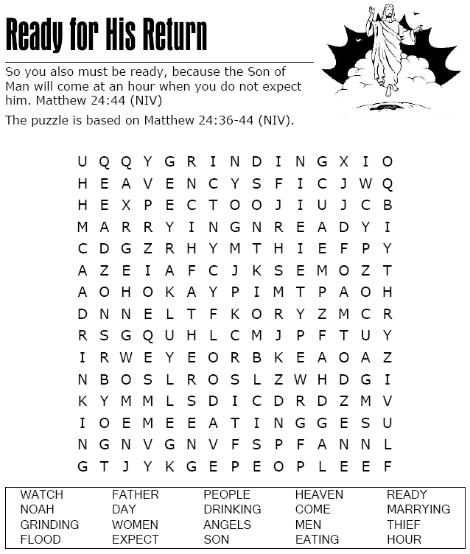
Decoder Puzzle  Each number represents a letter of the alphabet. Substitute the correct letter for the number to reveal the coded word.  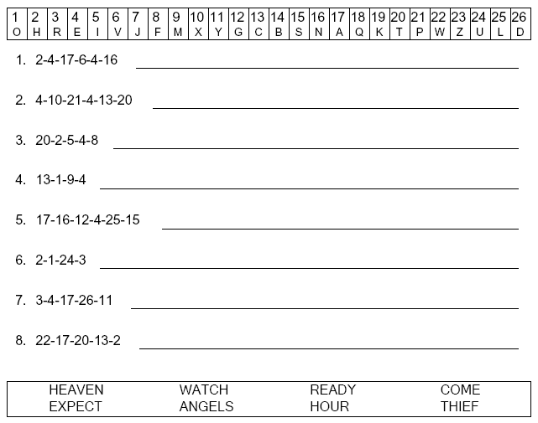 | 