Lesson #5 Matthew 10:1-42 Kingdom in Conflict

Review Last Week:
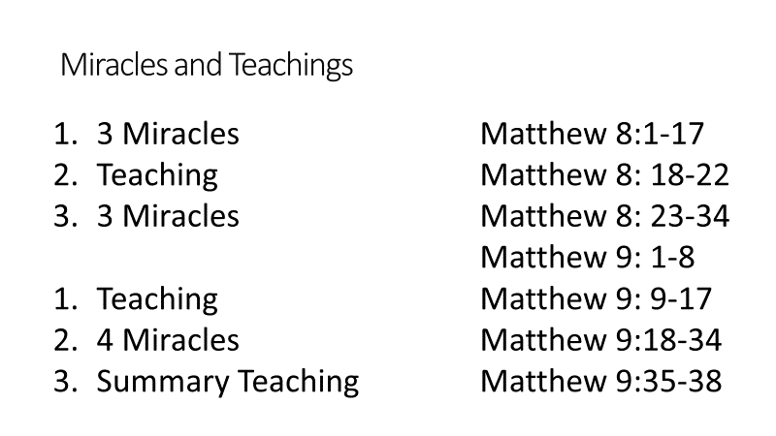 | 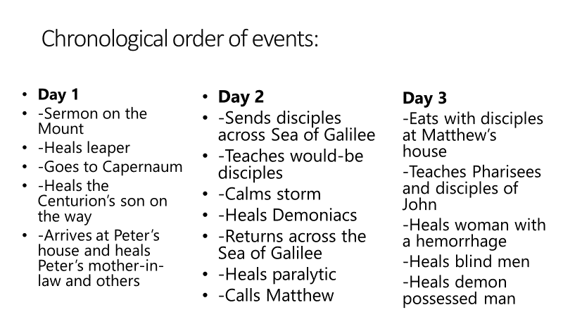

Intro – Matthew has shown Jesus as the King in many ways:
____________________________________________________________________________________________________________________________________________________________________________________

- This week’s lesson reviews Jesus’ sending out of His apostles to preach about His Kingdom
1. He Grants Them Power – 10:1 _____________________________________________________________
__________________________________________________________________________________________
2. He Names Them Apostles – 10:2-4 __________________________________________________________
__________________________________________________________________________________________

- Apostles are special messengers who:
- ____________________________________________________________________________________
- ____________________________________________________________________________________
- ____________________________________________________________________________________

- There were 12 apostles and later 14 in all:
______________________________________________________________________________________________________________________________________________________________________________________________________________________________________________________________________________

3. He Instructs Them Concerning Their Mission – Matthew 10:5-42
A. Ministry to Israel – vs. 5-10
- _________________________________________________________________________ vs. 5-6
- _________________________________________________________________________ vs. 7
- _________________________________________________________________________ vs. 8
- _________________________________________________________________________ vs. 9
- _________________________________________________________________________ vs. 11-15

B. He Warns Them – Matthew 10:16-23
- Not always a good response - Vs. 16-18 ___________________________________________________
___________________________________________________________________________________
- Jesus will provide – Vs. 19-20 __________________________________________________________
___________________________________________________________________________________
- Results of their preaching – Vs. 21-23 _____________________________________________________
____________________________________________________________________________________
C. He Instructs Them on Their Response – Matthew 10:24-33
- _________________________________________________________________________ vs. 24-25
- _________________________________________________________________________ vs. 26-33
D. Jesus Explains the People’s Reaction – Matthew 10:34-39
- _________________________________________________________________________ vs. 34-36
- _________________________________________________________________________ vs. 37-39
E. His Promises to Those who do Respond – Matthew 10:40-42
____________________________________________________________________________________________________________________________________________________________________________________

Summary
____________________________________________________________________________________________________________________________________________________________________________________
Jesus still sends His servants out today.
- He calls ____________________________________________________________________ Acts 2:37-47
- He equips _____________________________________________________________________ Acts 2:38
- He instructs ______________________________________________ Matthew 28:18-20; II Timothy 3:16
- He encourages _______________________________________________________ II Thessalonians 2:17

Jesus tells us the same things:
- Don’t ________________________________________________________________________________
- Don’t ________________________________________________________________________________

LITTLE LEARNERS
Matthew 10
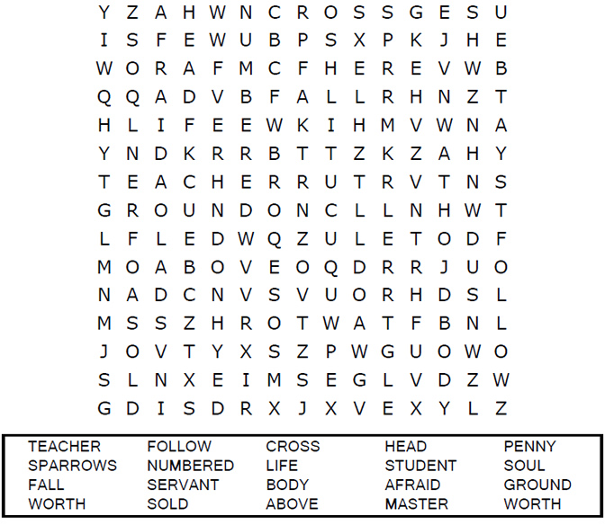  Each number represents a letter of the alphabet. Substitute correct letter for the numbers to reveal the coded words.  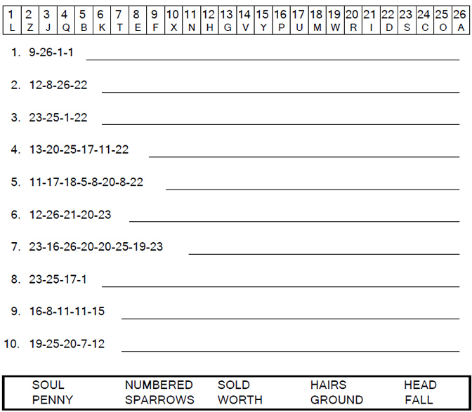 | 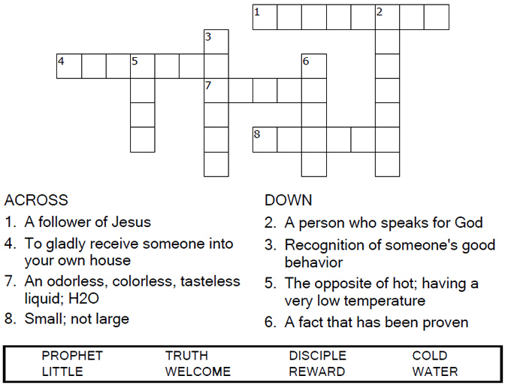  Each number represents a letter of the alphabet. Substitute correct letter for the numbers to reveal the coded words.  